GDAL is the abbreviation of Geospatial Data Abstraction Library, which is a fundamental package for spatial analysis with Python. GDAL has a lot of powerful functionality. However, it is notorious for difficult installation. In the document, I will introduce how to use Anaconda (conda) to install GDAL and run Jupyter notebook kernel in different environments create by conda.

1 Create a new running environment for GDAL using the following command.

*Conda create -n* ***ENV NAME*** *python=* ***VERSION NUMBER***

The italic and bold parts can be defined by yourself as shown in the following.

2 Use *conda activate ENV NAME* to activate the environment.

3 Install the packages of notebook and ipykernel

4 Create a default Jupyter notebook kernel for the current virtual environment.

*Python -m ipykernel install --user --name* ***ENVNAME*** *--display-name* ***"Python (whatever you want to call it)"***



5 Use the command of ‘jupyter notebook’ to run Jupyter. When creating a new Jupyter notebook, we will find that all Jupyter kernels are listed. We can choose a kernel based on our demand.

6 Use the command of ‘conda install -c conda-forge gdal’ to install GDAL package

7 Create a new Jupyter notebook with the kernel of ‘env_gis_py37’ I just created in step 5. The GDAL distribution from **conda-forge** installs **GDAL** as part of the **OSGEO** library, which includes **GDAL**, **OGR**, and **OSR**. Just use ***from osgeo import gdal***. If nothing happens then **gdal** was successfully imported.

8 Based on the GDA library, we can successfully install **Fiona, shapely, geopandas, rasterio.** When you firstly install **Fiona**, **shapely** will be automatically installed.

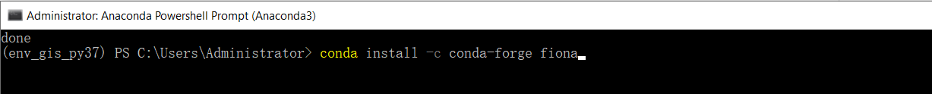

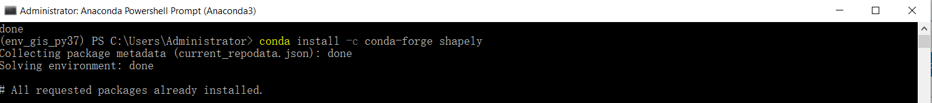

No errors happen. These packages have been successfully installed.